

Swipes & Tags
The official newsletter of the Sacramento Capitolaires, Sacramento,
California Chapter of the Far Western District of the Barbershop
Harmony Society

Special Issue – A Time for Change!
Where Singing Happens!
71 YEARS OF BARBERSHOP SINGING IN SACRAMENTO
___________ Chartered June 14, 1946 ______ Fall 2017

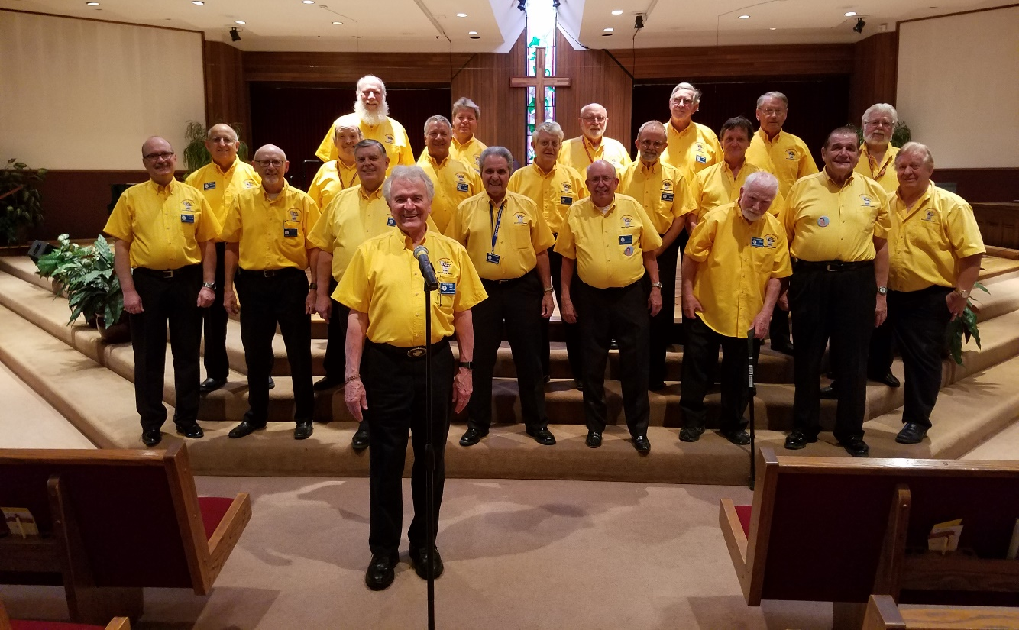

Thank you Ray Rhymer for directing our chapter from August, 2013 until September, 2017.
Pictured above, Ray addresses the Capitolaires and guests during our 70th Anniversary program in 2016.

The editor asked Ray about his recent decision to resign as our director and what were his future plans.

Decision to resign: “Being a front line Music Director is an honor and privilege – one that requires a
significant commitment of time and effort. My Barbershop directing experience began with a small
struggling chapter in 1965. The members were looking for anybody who might be able to help, so I tried.
I knew enough to be able to stand up front and wave my hands to a beat, and could read music, but that
was about it. It was OK for a while, but was destined not to last, and it didn’t.

___________________________________________________________________________________

The Sacramento Capitolaires meet every Tuesday at 7:00 p.m. in Christ Community Church,
5025 Manzanita Avenue, Carmichael. Check out our website www.capitolaires.org or phone (888) 877-9806.
____________________________________________________________________________________________________

That experience started me down the path of learning how to direct a Barbershop chorus. BHS schools
were and are wonderful for learning Barbershop skills, including directing. I directed several chapters
over a span of 52 years – the longest tenure was with Placerville (15 years).

As with all of us, I have personal expectations when I take on a significant commitment. I’ll be 82 years
old September 15th, and age is taking its toll. One consequence is I am not living up to my expectations
as a Barbershop Music Director. For me, the song title You Can’t Do The Things You Used To Do,
Thirty-five Years Ago says it all at this stage of my life. Therefore, I step down as director of the
Sacramento Capitolaires, effective September 15th, 2017.

I am no longer able to stand statically for any period of time in a chorus (or quartet) rehearsal, whether
in front of a chair or on the risers – just too much for my back. As a director, I am able to keep moving,
which relieves the issue.”

Future Plans: “I’ve found over the years that I am terrible at predicting the future. My specific commit-
ment is to continue as the Editor of Westunes (the quarterly Far Western District online magazine) for
the foreseeable future. I will also continue as the 2017 Sacramento Music & Performance VP, at least
until the 2018 chapter officer election.

Incoming director Chris McCuddy is a very talented young man, and has Ron Black as his mentor. Ron
taught Chorus Directors at Harmony University for years, so Chris is very fortunate to have an expert
teacher as a mentor. The Capitolaires are fortunate to have both Chris and Ron supporting the chapter.

Some years ago, I decided to live to be 100 and then figure out what to do with the rest of my life. That
thought continues to this day <smile>.

Remember, it is OK to Encourage, Enthuse, Excite and Enjoy.” Ray

Welcome, Chris McCuddy! He is the Capitolaires new director effective on September 19, 2017.



Western Harmonics Quartet includes our new director, Chris McCuddy-second from left.

Chris was born in Sacramento and grew up in Shingle Springs and Placerville. He currently lives in
Folsom..Chris graduated from El Dorado High School in 2015 and is currently pursuing two Bachelor of
Music Degrees, one in Music Education and one in Keyboard performance at CSUS.

Chris works as a Sales Manager and Maintainer of Band Instruments at Kline music store in South
Sacrameno, where he works with the customers and cleans band instruments. His hobbies include
playing classical music, singing barbershop and tennis..Chris sings baritone in his quartet.. He has
also sung choral music and vocal jazz. “I can play and teach pretty much all band instruments.” Chris
plans to be a school teacher.

“I started my barbershop career in high school when my Band Director introduced me to the hobby in
the Placerville chapter. I soon joined and continued there for a while.Then dual members of Placer-
ville introduced me to VoCal and I have been there ever since. I have been to each type of convention
so far, District in 2016 (Riverside), Division and International both in 2017 (Sacramento and Las Vegas
respectively). I competed with VoCal in all three and also directed Placerville Chapter in contest at the
division competition this year. I have also been to Harmony University in the Next Generation Chorus,
and also performed with VoCal the same week, and my elective class was conducting with Rob Mance,
the Central Standard Director.”

 Comments from our Chapter President

Clark Abrahamson
“Some 35 years ago I attended my first Sacramento Capitolaires Chapter Meeting. I was a mere 45 years old, As I recall, was slightly below the average age of the Capitolaires membership at the time.
I was warmly greeted and introduced to the guys. At the time, we were the large chapter – over 100 members. At break time, someone took me aside and taught me a tag. I was hooked!

I recall how impressed I was by the Director, also a ‘youngish’ guy about my age, by the name of
Ray Rhymer, as he masterfully took the guys through the repertoire of the time, which included
songs like If You Knew Susie, That Old Quartet of Mine, This is My Country, Keep Your Sunny
Side Up/Smile medley and others, the names of which escape me.

Over the years, I got to know Ray quite well, as a Director, Coach, Judge, Quartet guy, fellow
Leadership Academy (once known as Chapter Officer Training School – COTS) Instructor, Westunes
editor and friend.

Now 35 years later, in September, we celebrate two very important milestones in Ray’s life -
his retirement as Capitolaires Director and his Eighty-Second birthday. Please join me in wishing
Ray the very best, in the hope that he’ll remain with the ‘CAPS’ as a valued member, mentor, coach, and friend – for the foreseeable future.

I know that Ray joins me, as I’m certain we all do, as we celebrate another milestone – that of
welcoming our new, young, dynamic, multi-talented Director, Chris McCuddy to the proud brother-
hood of the Sacramento Capitolaires!”

Editorial Comments

This Special Issue of the Swipes & Tags does not include all the news but is to inform the membership about the recent chapter changes. I am grateful for the articles I received from Ray Rhymer, Chris McCuddy and Clark Abrahamson.

Editor Joe Samora at tm39samora@comcast.net , a proud member of PROBE (Public Relations Officers and Bulletin Editors) since 2008.

